St. Malachy’s College,

Belfast

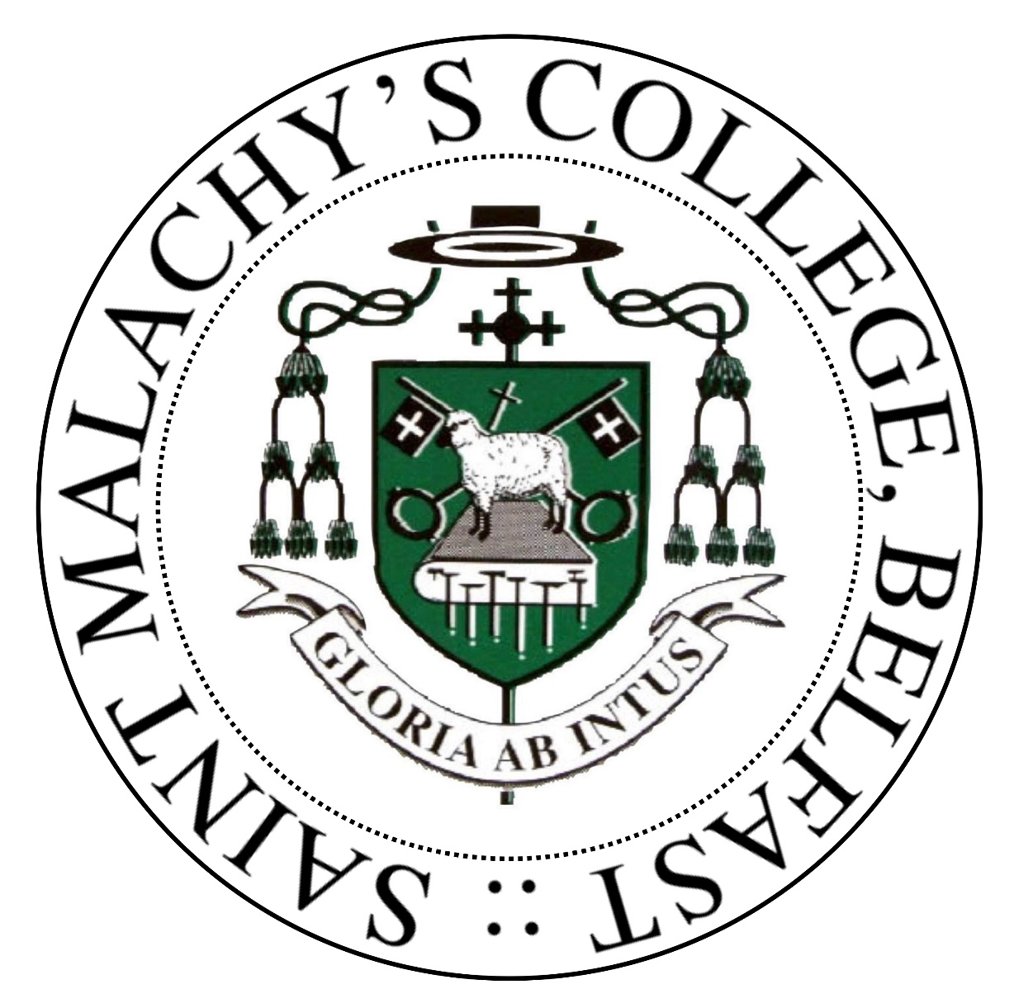

1. Examination Results 2021-22
2. Curriculum Details 2022-23

**Examinations**

The College continues to produce personal bests in GCSE, AS and A2 Examination results. Prior to the pandemic, the Education Training Inspectorate commended the College on its academic outcomes. Having emerged from the past few challenging Covid years when schools and colleges were tasked with assigning grades to all students, the College returned in 2022 to actual examinations. We can report that the College has again produced an excellent set of results with evidence of sustaining improvement and upward trends.

**GCSE**

All year 12 students are entered for GCSE examinations with the following examination boards:

* Computing - WJEC
* All other subjects - CCEA

|  |  |
| --- | --- |
| Category |  |
| Number of students in Year 12 | 167 |
| Number of Students level 5 SEN | 11 |
| % entered for 5 or more GCSEs | 100% |
| % achieving 5 or more GCSEs | 98.2% |
| % achieving 5 or more GCSEs including English & Maths | 98.2% |
| % entered for 7 or more GCSEs | 100% |
| % achieving 7 or more GCSEs | 95.7% |
| % achieving 7 or more GCSEs including English & Maths | 95.7% |

**GCSE Results by Subject**



|  |  |  |  |  |  |  |  |  |  |  |  |  |  |  |  |  |
| --- | --- | --- | --- | --- | --- | --- | --- | --- | --- | --- | --- | --- | --- | --- | --- | --- |
| Subject | Ent | ** | *A | AA | AB | BB | BC* | C** | C*C | CC | CD | DD | DE | EE | EF | % A*-C |
| Science Double Award (1370) | 122 | 11 | 13 | 28 | 10 | 14 | 13 | 12 | 10 | 4 | 1 | 1 | 1 | 1 | 1 | 94.3% |

**A Level**

|  |  |
| --- | --- |
| Category |  |
| Number of Students in Year 14 ( Exam Cohort) | 121 |
| Number of students level 5 SEN | 6 |
| % achieving 3 or more A level passes grades A*-C | 83.3% |
| % achieving 3 or more A Level passes grades A*-E | 95.0.% |

* 83.3 % of students achieved Grades A*- C in 3 or more subjects
* 63.0 % of students achieved Grades A*- B in 3 or more subjects

**A Level Results by Subject**

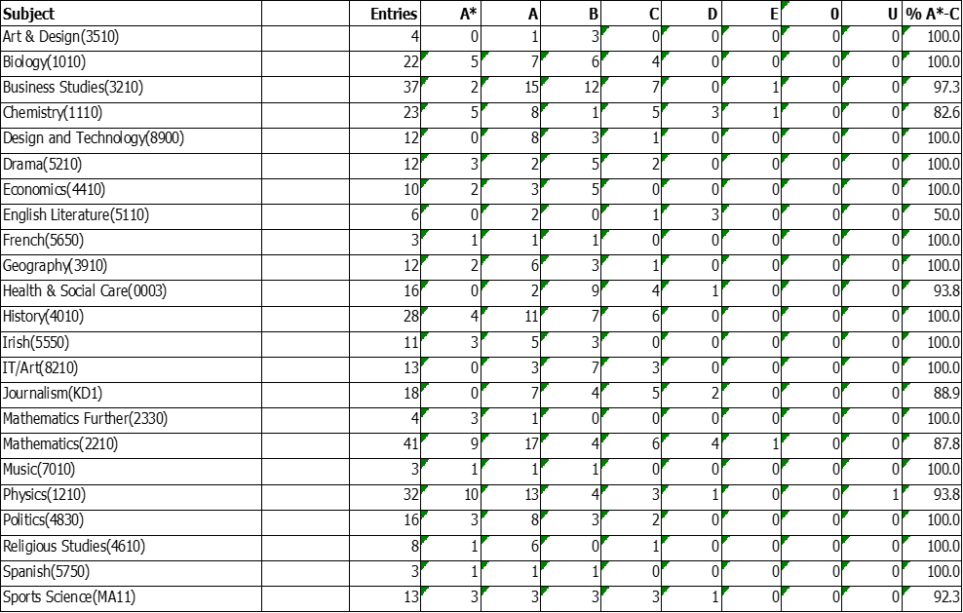

**Performance in Public Examinations 2018/19 - 2021/22**

|  |  |  |  |  |  |  |  |  |
| --- | --- | --- | --- | --- | --- | --- | --- | --- |
|  | 2018-19 | | 2019-20 | | 2020-21 | | 2021-22 | |
| School | NI Average  (Boys’ Grammar) | School  (CAGs) | No NI  Data Available | School  (CDGs) | No NI Data Available | School | No NI Data Available |
| % achieving 5+ GCSEs at Grade A*-C | 98.2% | 93.8% | 96.9% | **-** | 97.4% | **-** | **98.16%** | **-** |
| % achieving 7+ GCSEs at Grade A*-C | 91.6% | 86.6% | 93.8% | **-** | 94.12% | **-** | **95.71%** | **-** |
| % achieving 3 + A Levels at Grades A*-C | 75.5% | 74.4% | 100% | **-** | 93.5% | **-** | **83.3%** | **-** |
| % achieving 2 A Levels at Grades A*-E | 100% | 99.3% | 100% | **-** | 100% | **-** | **100%** | **-** |

**Destination of Leavers in 2021/22**

|  |  |  |  |  |  |  |
| --- | --- | --- | --- | --- | --- | --- |
| Year Group | No. of Pupils in Year Group | % to Higher Education | % to Further Education | % to another school | % in Employment | % Other |
| 14 | 124 | 88.8% | 4.8% | 0% | 3.2% | 3.2% |

**Curriculum Details 2020-21**

St. Malachy's, as a Diocesan College, aims to create a Catholic ethos in which students flourish and develop **all** their talents. The school therefore begins from the principle that its curriculum, which is seen as the total range of learning experiences and activities provided by the College, including its pastoral provision, is intentionally directed to the growth of the whole person. Belief in a God of love, justice and forgiveness is seen as being essential to this process.

The College motto *Gloria ab Intus* (Glory from within)reflects our conviction that education is not merely concerned with the imparting of information but is also about helping young people to mature as individuals, developing in them a strong emotional resilience in preparation for life beyond the College. The College seeks to preserve its traditions of spirituality and learning so that all pupils and staff can experience continuity in achievement and further their own spiritual, educational and personal growth in a pleasant, interesting and stimulating environment.

**SUMMARY OF CURRICULUM PROVISION**

**KEY STAGE 3**

In years 8 and 9 all pupils follow a similar curriculum, which includes a total of sixteen subjects including discrete provision for Learning for Life and Work (LLW). Elements of LLW are also infused across the learning areas, along with opportunities for the development and assessment of the cross-curricular skills (Communication, Digital Skills, Using Maths).

Art & Design Science

Physical Education Technology

Drama Home Economics

Music Mathematics

English Geography

2 of French/Irish/Spanish History

Religious Studies Digital Skills

LLW

LLW includes the delivery of:

* Personal Development
* Citizenship
* Employability

In year 10 extra time is given to Employability in preparation for GCSE and important career choices. In addition, the three sciences are delivered by specialist teachers and taught as three individual strands

**KEY STAGE 4: Choice of subjects at GCSE**

**Core Subjects:**

* English Language
* English Literature
* Mathematics
* Religious Studies

**Sciences:**

* Single Award Science
* Double Award Science
* Triple Award Science (Physics, Chemistry and Biology)

**Languages:**

* French
* Gaeilge
* Irish
* Spanish

**Options:**

* Art and Design
* Business and Communication Studies (BACS)
* Business Studies
* Computer Studies
* Drama
* Further Mathematics
* Geography
* History
* Home Economics
* LLW
* Leisure and Tourism
* Moving Image Arts
* Music
* Physical Education
* Technology and Design

**KEY STAGE 5: Choice of subjects at A2 and AS level**

The Sixth Form Curriculum aims to build upon the foundations laid in KS4.

The College tries to accommodate any combination of subjects. Pupils normally study three subjects for AS, pupils with a strong GCSE performance are encouraged to study a fourth subject at GCE AS-level. Most students take three subjects through to A2 level but some may continue to study four.

The following subjects are currently being offered at AS-level: (2021-22)

Applied ICT Art & Design Biology

Business Studies Chemistry Computing (SSD)

Design & Technology Drama Economics

English Literature French Further Mathematics

Financial Capability Geography Health & Social Care

History Home Economics Irish

Mathematics Moving Image Arts Music

Physics Politics Religious Studies

Sociology Spanish Sport Studies

Travel & Tourism

Some of these subjects are offered through collaboration with other schools from within the North Belfast Area Learning Community.

All pupils are required to supplement their A-level studies by taking additional courses in Religious Education (except for students taking A-level Religious Studies) and Careers Education. Students are encouraged to include time for Physical Education (personal fitness training) as well as partaking in the Enrichment programme and Voluntary Service programme. These additional courses are offered to broaden the educational experience of the pupils by providing access to knowledge, understanding and skills in a greater range of curricular areas. All students also have a weekly tutorial period.