Year 12 3 Week Revision Programme and Planner

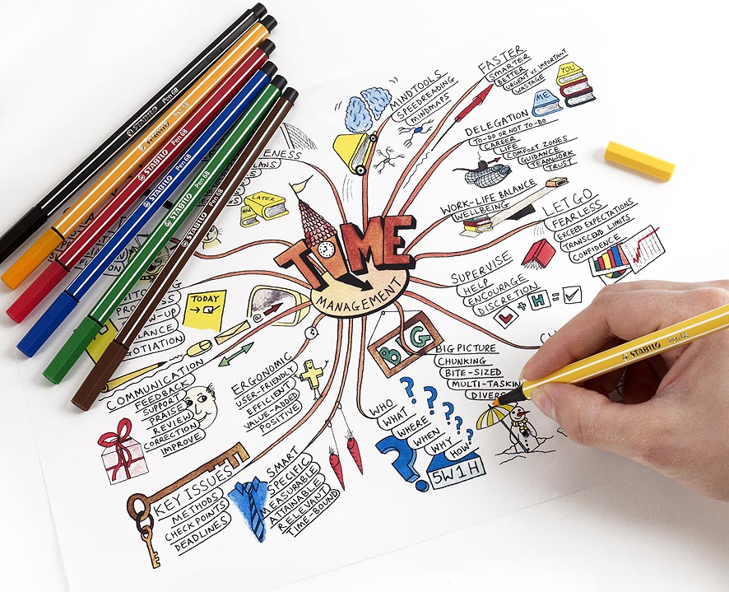

NAME CLASS

Week 1:

Subject | Topics to be covered
BACS | Types of Business Ownership
Business Studies | Human Resources (Recruitment, Selection, Appraisal, Training, Motivation)
Comp Studies | Networks
DA/TA Biology | Unit 2: Osmosis and Plant Transport – See Specification - Booklets from Biology teacher e-copy of revision guide on Showbie: KZVTM
DA/TA Chemistry | DA – Metals and Reactivity Series TA – Metals and Reactivity
DA/TA Physics | Unit 2: Waves, Echoes, Light and Lenses – See Specification – Year 11 Booklets 1 and 2
Drama | Re-read Philadelphia Here I Come! and complete costume revision for all characters in Episode One and Two  Public Gar, Private Gar, S.B., Madge, Katie Doogan, Katie King, Aunt Lizzy, Senator Doogan, Ned, Tom, Joe, Master Boyle, Ben Burton, Con Sweeney.
English | Analysing Non-Fiction Texts (English Language)
French | Context 1 Identity, Lifestyle and Culture  - Self, Family, Friends and Relationships  - Free time, Leisure, Daily Routine (Oral Topic)  - New technology and Social Media  Context 2 Local, National, International and Global Areas of Interest  - Home and environment  Context 3 School Life, Studies and the World of Work  - School (Extended Writing)  Core Revision Topics: Numbers, Countries, Opinions and Reasons, Time Frames, Food, Household Tasks, Weather,  Key Grammar Points: Present, Perfect and FutureTense, Adjectives, Reflexive Verbs, Higher Structures (See Notebook)  Resources: French Notebook, French Oral Booklets, CCEA Vocabulary Book, QUIZLET, Revision Powerpoints  (CCEA French Microsite)
Further Maths | Simplifying Algebraic Expressions  Add, subtract, multiply and divide rational algebraic fractions with linear and quadratic numerators and/or denominators  Manipulate algebraic expressions, including the expansion of three linear brackets  Equations  Form and solve linear equations including fractional terms  Form and solve quadratic equations using methods of factorising, formula and completing the square  Simultaneous Equations  Form and solve equations, sometimes given in context, in two or three variables, including:  Up to three linear equations in three unknowns; and one linear and one quadratic equation in two unknowns  Quadratic Inequalities  Solve quadratic inequalities, which are restricted to quadratic expressions that factorise  Trigonometry  Sketch the graphs of sin x, cos x and tan x, where the range of x is a subset of -360 ≤ x ≤ 360  Solve simple trig equations with a maximum of two solutions in a given range
Gaeilge | an Ghaeltacht - Irish language communities in the Gaeltacht and/or urban Gaeltacht; Irish language globally; aspects of Irish culture; place names, local history and heritage; and Irish language groups and societies;  Resources: Topic booklet, notes in your exercise book, textbook and oral answer booklet
Geography | Population growth, change and structure & causes and impacts of migration
HE | Food production/ food processing and production
History | Co-operation ends and the Cold War begins 1945 & Emerging superpower rivalry and its consequences, 1945–49 (see specification for more details)
Irish | Aimsir Cháite / Aimsir Láithreach / Aimsir Fháistineach  - Past tense verbs – regular and irregular, positive, negative and question form  - Present tense verbs – regular and irregular, positive, negative and question form  - Future tense verbs – regular and irregular, positive, negative and question form
Leisure & Tourism | Marketing, The Marketing Mix, Product, Price, Place & Promotion
Maths (M7/M8) | Constructions (Use a ruler and a pair of compasses to do constructions) to include drawing triangles and other 2D shapes using a ruler and a protractor  Loci (Use a ruler and a pair of compasses to do constructions)  Identify the loci of points, including real life problems  Use and interpret maps, scale factors and scale drawings  Ratio Use ratio notation, including reduction to its simplest form and its various links to fraction notation  Divide a quantity into a given ratio  Apply ratio and proportion to real-life contexts and problems such as conversion, best-buy, comparison, scaling, mixing, concentrations and exchange rates  Understand the Principles of Number Systems  Convert numbers from decimal to binary (base 2) and vice versa  Laws of Indices  Use index laws in algebra for zero, positive and negative powers,  Use index laws in algebra for integer powers  M8: Use index notation and index laws for integer, fractional and negative powers
Music | - Handel ‘For unto us a child is born’  - Mozart ‘Horn Concerto No.4 third Mvt’  - Berlioz ‘ Symphonie Fantastique’  Wks 1-3  - Unseen Baroque/Classical/Film/Irish Listening Questions
PE | Skeletal system 13-17  Muscular system 17-22  Physical health: sleep 76-79  Health –Mental and Social 37-45  Smoking, alcohol and illegal drugs 80-93  Fitness testing for wellbeing 60-62
RE | - The causes and types of prejudice and discrimination, including race, religion, gender and disability;  - Biblical and church opinions on prejudice and discrimination;  - Bible teaching on responsibility towards people in need;
Spanish | Context 1: Identity, Lifestyle and Culture  - Revision of ‘myself, my family and relationships’ vocabulary in languages guide 1 (light blue booklet) – pages 3-6  *DON’T FORGET TO USE QUIZLET TO ASSIST WITH ALL VOCABULARY REVISION!!!  - Revision of ‘culture, customs, festivals and celebrations’ vocabulary in language guide 1 (light blue booklet) – pages 6-7  Context 1: Identity, Lifestyle and Culture  - Revision of ‘free time, leisure and daily routine’ vocabulary in language guide 2 (light blue booklet) – pages pages 6-11  - Revision of ‘social media and new technology’ vocabulary in language guide 2 (light blue booklet) – pages 4-6  Grammar:  - Revision of present tense notes in grammar guide (green booklet) – pages 81-92  WRITING:  - As part of your written exam, you will be required to produce an extended piece of writing (of 150-180 words) on the topic of Home and Local Area
Tech. Design | Pneumatics
NB Year 12 LLW – only students that are repeating Yr11 modules in May 2020 will sit a Christmas exam.

Week 1:
TIME | MONDAY | TUESDAY | WEDNESDAY | THURSDAY | FRIDAY | SATURDAY | SUNDAY
8-9
9-10
10-11
11-12
12-1
1-2
2-3
3-4
4-5
5-6
6-7
7-8
8-9
9-10
Week 2:

Subject | Topics to be covered
BACS | Stakeholders
Business Studies | Business Growth (Business success/failure, Internal and External Growth, Economies of Scale)
Comp Studies | Central Processing Unit and Computer Memory
DA/TA Biology | Unit 2: The Circulatory System - See Specification - Booklets from Biology teacher e-copy of revision guide on Showbie: KZVTM
DA/TA Chemistry | DA & TA – Rusting, Redox and Iron
DA/TA Physics | Unit 2: Electricity and Electromagnetism – See Specification – Year 11 Booklets 3 and 4
Drama | Prepare performance and Director notes for Episode One of Philadelphia, Here I Come!
English | Writing for Purpose and Audience (English Language)
French | Context for Learning 2: Where I live, local area and region. Travel and tourism.  Grammar: Revision of future and conditional tenses
Further Maths | Differentiation  Differentiation of powers and sums of powers of x to find dy/dx and d²y/dx²  Applications of Differentiation  Apply the method of differentiation to:  Gradients, tangents, normals, maximum and minimum turning points  Elementary curve sketching of a quadratic or cubic function (a cubic function will have x as a common factor)  Integration  Integration of powers and sums of powers of x, including definite integration (Including negative indices but excluding fractional indices and ∫ x⁻¹ dx)  Form and evaluate definite integrals  Application of definite integration to find the area under a curve.  Area enclosed between a curve, the x-axis and the ordinates x = a and  x = b.
Gaeilge | Myself and the world around me - issues affecting teenagers in today’s world; personal issues; social problems; health and lifestyle; social media; modern technology; and environmental issues;  Resources: Topic booklet, notes in your exercise book, textbook and oral answer booklet
Geography | Urban land use & issues facing inner city areas in MEDCs
HE | Macro and micronutrients, fibre and water
History | Flashpoints in Europe and the impact on international relations 1948-68: egs. Berlin Blockade/Airlift 1948-49, Hungary 1956, Berlin 1959-1961 and Czechoslovakia 1968 (see specification for more details)
Irish | - Free time and Leisure:  - Vocabulary for hobbies, sports, expressing an opinion with a reason  - How you spent / spend / will spend your weekend  - What you like to do in your spare time  - Resources: Topic booklet, notes in your exercise book, textbook and oral answer booklet
Leisure & Tourism | Target Marketing, Market Segmentation, E Marketing – Impact of the Internet and Social Media
Maths (M7/M8) | Changing the Subject of a Formulae  Include cases where the subject appears in more than one term or where a power or root of the subject appears  Transformations  Describe and transform 2D shapes using single transformations  Describe and transform 2D shapes using reflections about the x and y axes, in lines parallel to the x and y axis and y = ± x  Distinguish properties that are preserved under particular transformations  Describe and transform 2D shapes using single rotations about the origin and any point  Describe and transform 2D shapes using translations, to include vector notation  Describe and transform 2D shapes using enlargements by a positive whole scale factor and fractional scale factor  Recognise reflection and rotational symmetry of 2D shapes  Describe and transform 2D shapes using single or combined rotations, reflections, translations or enlargements by a positive, fractional and negative scale factor  Simultaneous Equations  Revision of drawing a straight line  Solve two linear simultaneous equations graphically  Set up and solve two linear simultaneous equations algebraically  M8: Set up and solve two simultaneous equations, one linear and one non-linear
Music | - Williams ‘Superman, Main Theme’  - Horner ‘The Amazing Spider-Man, Young Peter’  Wks 1-3  - Unseen Baroque/Classical/Film/Irish Listening Questions
PE | Physical fitness 142-147  Principles of training 147-150  Methods of training 150-156  The leisure industry 102-113  Event management in the Active Leisure Industry 114-122  Health, Safety and Risk Assessment 63-65
RE | - The causes and characteristics of local, national and global poverty, and the distinction between absolute and relative poverty;  - The work of one organisation fighting poverty and injustice, for example Christian Aid, St Vincent de Paul, Salvation Army or Trócaire;  - Ways in which individuals and communities can respond to and support both fair trade and campaigns for justice;
Spanish | Context 2: Local, National, International and Global Areas of Interest  - Revision of ‘health and lifestyle’ vocabulary in language guide 3 (yellow booklet) – pages 4-9  - Revision of ‘antisocial behaviour and caring for others’ vocabulary in language guide 3 (yellow booklet) – page 3  Context 2: Local, National, International and Global Areas of Interest  - Revision of ‘travel and tourism’ vocabulary in language guide 4 (yellow booklet) – pages 4-7  Grammar  - Revision of preterite tense notes in grammar guide (green booklet) – pages 109-115  - Revision of adjectives notes in grammar guide (green booklet) – pages 30-33
Tech. Design | Mechanisms

Week 2:

TIME | MONDAY | TUESDAY | WEDNESDAY | THURSDAY | FRIDAY | SATURDAY | SUNDAY
8-9
9-10
10-11
11-12
12-1
1-2
2-3
3-4
4-5
5-6
6-7
7-8
8-9
9-10
Week 3:
Subject | Topics to be covered
BACS | Communication
Business Studies | Finance (Sources of Finance, Cash flow Forecasts, Financial Statements, Ratios, Break-even)
Comp Studies | Computer Arithmetic
DA/TA Biology | Unit 2: Chromosomes, Genes and DNA - See Specification - Booklets from Biology teacher e-copy of revision guide on Showbie: KZVTM
DA/TA Chemistry | DA & TA – Rates of Reaction and Equilibrium
DA/TA Physics | Unit 2: Space Physics and Unit 1 Motion, Newton’s Laws and Hooke’s Law – See Specification – Year 11 Booklet 5, Year 12 Booklets 1 and 2
Drama | Prepare performance and Director notes for Episode Two of Philadelphia, Here I Come!
English | Analysing Non – Fiction Texts (English Language)
French | Context for Learning 3: School life, studies and jobs  Grammar: Higher Structures. Opinions and reasons. Linking phrases
Further Maths | Matrices  Add and subtract matrices  Multiply matrices including compatibility rule for multiplying  Find det A and A⁻¹for 2x2 matrices  Solve equations of the form A ± X = B and AX = B  Solve two linear simultaneous equations using matrices  Logarithms  Understand logarithms as a natural evolution from indices  Use the three basic laws of logarithms in simplifying and manipulating expressions involving logarithms  Solve indicial equations using logarithms  Log graphs in context
Gaeilge | - Past/present/future tense verbs.  - Prepositions, the infinitive form of the verb & rules of mo/do/a etc  Resources: Topic booklet, notes in your exercise book, textbook and oral answer booklet
Geography | Urbanisation in MEDCs and LEDCs
HE | Nutritional and dietary needs, CVD and Diabetes
History | Flashpoints outside Europe and the impact on international relations 1950-65 eg Korean War 1950-53, Cuban Missile Crisis 1959-62 and background to Vietnam War 1950-65 (see specification for more details)
Irish | Daily Routine  - How you spent/spend/will spend the weekend (opinions and idiomatic languages)  Resources: Topic booklet, notes in your exercise book, textbook and oral answer booklet
Leisure & Tourism | Organisational Objectives, Promotional Activity, Market Research
Maths (M7/M8) | Surds  Use surds and π in exact calculations  M8: Distinguish between rational and irrational numbers  Change a recurring decimal to a fraction  Simplify numerical expressions involving surds, including the rationalisation of the denominator of a fraction  Standard Form  Interpret, order and calculate with numbers written in standard index form  Inequalities  Solve inequalities in one variable, and represent the solution set on a number line  Solve linear inequalities in two variables representing the solution set on a graph  Sequences  Recognise and use sequences of, for example, triangular, square and cube numbers  Generate terms of a sequence using term-to-term or a position-to-term rule  Find the nth term of a sequence where the rule is linear  Find the nth term of non-linear sequences  Trigonometry  Understand and use bearings  M8: Understand and use the sine and cosine rules  Calculate the area of a triangle using  A =  Use Pythagoras’ theorem and trigonometry to solve 2D and 3D problems
Music | ➢ Beoga ‘Prelude Polka, Paddy’s Polka No.2, Millstream Reel’  ➢ Stonewall Folk Group ‘The Boys of Belfast/The Girl I Left Behind’  Wks 1-3  ➢ Unseen Baroque/Classical/Film/Irish Listening Questions
PE | Assessment of physical fitness 156-159  Planning and evaluating training programmes 159-162  Planning and evaluating training sessions 162-170  Cardiovascular System 23-27  Respiratory System 28-30
RE | - The debate about abortion, taking account of social, political, biblical, church and other ethical viewpoints;  - The views of pro-life and pro-choice groups, the status of the embryo, sanctity of life and alternatives to abortion;
Spanish | Context 2: Local, National, International and Global Areas of Interest  - Revision of ‘my local area and the wider environment’ vocabulary in language guide 5 (yellow booklet) – pages 2-11  - Revision of ‘social issues’ vocabulary in language guide 5 (yellow booklet) – page 12  Grammar  - Revision of near future tense notes in ‘myself, my family and relationships’ languages guide 1 (light blue booklet) – pages 45-46  - Revision of possessive adjectives notes in grammar guide (green booklet) – pages 48-50  - Revision of negatives notes in grammar guide (green booklet) – pages 35-36
Tech. Design | Materials
Week 3:

TIME | MONDAY | TUESDAY | WEDNESDAY | THURSDAY | FRIDAY | SATURDAY | SUNDAY
8-9
9-10
10-11
11-12
12-1
1-2
2-3
3-4
4-5
5-6
6-7
7-8
8-9
9-10

