Year 11 3 Week Revision Programme and Planner

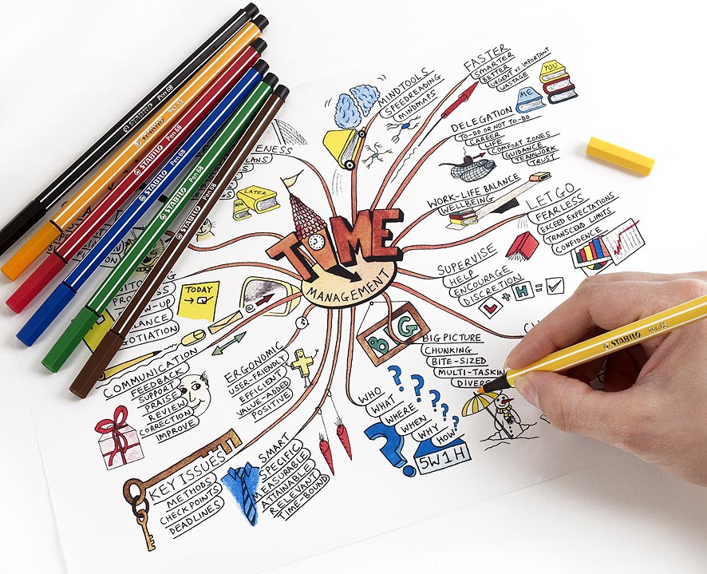

NAME CLASS

Week 1:

Subject | Topics to be covered
BACS | Creating tables in Access, choosing data types & applying validation rules.  Creating relationships between two tables.
Business Studies | Business Ownership: Sole trader, Partnership, Private Limited Company, Public Limited Company, Franchise, Social Enterprise, the Public Sector
Comp Studies | Computer Arithmetic
DA Biology | Cells:  - Animal, plant and bacterial cells  - Using a microscope to examine plant and animal cells  - Multicelled organisms and specialisation  Showbie code: KZVTM  This has an electronic copy of the CCEA revision guide which is suitable for both Triple Award and Double Award Biology (note the instructions in the ‘About this book’ section).
DA Chem | Atomic Structure
Drama | Re-read Philadelphia, Here I Come Episode One only and do practise Costume questions (both parts) on Public and Private
English | Personal or Creative Writing
French | Topics: Self, Family, Friends, Relationships, Going Out  General Vocabulary: countries, subjects, jobs, numbers, opinions, food, clothes, Opinions, Time frames  Grammar: Present Tense, Adjectives, Reflexive verbs, Perfect tense, Simple Future Tense
Gaeilge | Na hAimsirí uilig / Past / Present / Future tense  - Past tense verbs – regular and irregular, positive, negative and question forms  - Present tense verbs - regular and irregular, positive, negative and question forms  - Future tense verbs - regular and irregular, positive, negative and question forms  Resources: Class notes, topic booklet, oral booklet, text book
Geography | The drainage basin: A component of the water cycle & river processes and landforms
HE | Food and Nutrition for good health  Current government guidelines:  - The 8 tips for eating well  - The Eatwell Guide  Energy and nutrients  - The factors which influence individual energy requirements  - The percentage of recommended energy values provided by protein, fat and carbohydrates
History | Hitler takes political control 1933-1934
Irish | Mé Féin agus Mo Theaghlach  - Name, age, where you live, school, class  - Physical description and personality  - Family – number, sisters, brothers, eldest, youngest, pets  - Do you get on with your family?  - Likes and dislikes  Resources: Class notes, topic booklet, oral booklet, text book
Leisure & Tourism | - The concepts of Leisure, Travel and Tourism.  - Types of Tourism.  - Why people use Leisure and Tourism facilities.  - Factors that influence the choice of Leisure, Travel and Tourism activity.  - Reasons for Leisure, Travel and Tourism visits.
LLW | Diversity and Inclusion: Challenges and Opportunities pg 7-33  Rights and Responsibilities: Local and Global Issues pg 34-42
Maths M3  BOW | Number work – add, subtract, multiply and divide whole numbers and decimals up to 3 d.p.  Place value, decimal places, significant figures  Odd, even, multiples, factors, square, triangle and cube numbers, reciprocals, powers and roots  Use index notation for squares, cubes and powers of 10  Prime numbers and expressing a number as a product of prime factors  Highest common factor  Lowest common multiple  Recognise that recurring decimals are exact fractions and that some fractions are recurring decimals  Understand and use the concepts and vocabulary of expressions, equations, formulae, inequalities, terms and factors  Know the difference between an equation and an identity  Interpret simple expressions as functions with inputs and outputs  Algebra – collecting like terms  Removing brackets  Factorisation  Manipulate algebraic expressions by taking out common factors that are constants
Maths M4 | Number work – add, subtract, multiply and divide whole numbers and decimals up to 3 d.p.  Place value, decimal places, significant figures  Odd, even, multiples, factors, square, triangle and cube numbers, reciprocals, powers and roots  Use index notation for squares, cubes and powers of 10  Prime numbers and expressing a number as a product of prime factors  Highest common factor  Lowest common multiple  Recognise that recurring decimals are exact fractions and that some fractions are recurring decimals  Understand and use the concepts and vocabulary of expressions, equations, formulae, inequalities, terms and factors  Know the difference between an equation and an identity  Interpret simple expressions as functions with inputs and outputs  Algebra – collecting like terms  Removing brackets  Factorisation  Manipulate algebraic expressions by taking out common factors that are constants
Music | Set Work: Handel (For unto us a child is born), revision of notes and score, and related Baroque listening. Dambusters Movie theme set work listening and related listening.
PE | Skeletal system 13-17  Muscular system 17-22  Health – Mental and Social Health 37-45
Physics | Waves
RE | The meaning and significance of the identity of Jesus, both for the disciples and for Christians today, through a study of key events relating to his titles as Son of God, Messiah, Son of Man, Son of David and Saviour:  - the ministry of John the Baptist Mark 1: 1–13;  - Peter’s declaration about Jesus Mark 8: 27–33;  - the Transfiguration Mark 9: 2–13
SA Science | ‘Elements, Compounds, Mixtures and Separating Techniques’ and ‘Atomic Structure and Periodic Table’
Spanish | Vocabulary: Myself, my family, relationships and choices (Pp. 3-6 of language guide 1 – light blue booklet)  *DON’T FORGET TO USE QUIZLET TO ASSIST WITH ALL VOCABULARY REVISION!!!  General vocabulary: numbers, dates, countries, opinions, high frequency words, and question words (Pp.17-22 of grammar guide – green booklet)  Grammar: Reflexive verbs in the present tense (Pp.82-84 of grammar guide)
TA Biology | Cells:  - Animal, plant and bacterial cells  - Using a microscope to examine plant and animal cells  - Electron microscopes  - Stem Cells  - Diffusion  - Multicelled organisms and specialisation  Showbie code: KZVTM  This has an electronic copy of the CCEA revision guide which is suitable for both Triple Award and Double Award Biology (note the instructions in the ‘About this book’ section).
TA Chem | Atomic Structure and Bonding
Tech. Design | Materials Woods, Metals & Plastics

Week 1:
TIME | MONDAY | TUESDAY | WEDNESDAY | THURSDAY | FRIDAY | SATURDAY | SUNDAY
8-9
9-10
10-11
11-12
12-1
1-2
2-3
3-4
4-5
5-6
6-7
7-8
8-9
9-10

Week 2:

Subject | Topics to be covered
BACS | Creating queries (including criteria & show only) and reports (including grouping & sorting)
Business Studies | Location, Business Aims, Mission Statements, Stakeholders
Comp Studies | Data Storage
DA Biology | Photosynthesis and plants:  - Photosynthesis  - Photosynthesis experiments  - Limiting factors in photosynthesis  - Leaf structure  - The relationship between photosynthesis and respiration  Showbie code: KZVTM  This has an electronic copy of the CCEA revision guide which is suitable for both Triple Award and Double Award Biology (note the instructions in the ‘About this book’ section).
DA Chem | Bonding and Structures
Drama | Costume question on Madge and Episode One from a Director’s point of view (Revise example questions we have done in class)
English | Personal or Creative Writing
French | Topic: Free time/leisure /sport  Grammar: Perfect tense/object pronouns/simple future
Gaeilge | Saol Na Scoile / School Life  - History of school, how many students and teachers  - Principal, type of school, where the school is situated  - Subjects and preferences  - Irish-Medium Education the advantages and disadvantages  - Typical school Day  - Future plans  - Advantages and Disadvantages of school  Resources: Class notes, topic booklet, oral booklet, text book
Geography | Sustainable management of rivers
HE | Macronutrients  - The functions and main sources of protein, fat and carbohydrates  - Protein (Including biological value and complementation)  - Fat: Saturated and unsaturated  - Carbohydrates: Sugars and starches  Water  - Functions and main sources of water  - The importance of hydration in the body
History | Control and Opposition
Irish | Ag Cur sios ar Dhaoine eile  - Parents occupations  - Describing a friend or family member  - Likes and dislikes  Social Media and New Technology  - Your opinion on social media and new technology  - Types of technology available  - Advantages and disadvantages of the above  Resources: Class notes, topic booklet, oral booklet, text book
Leisure & Tourism | - Components of the Leisure industry.  - Components of the Travel industry.  - Links between Leisure, Travel and Tourism components.
LLW | Government and Civil Society: pg 43-52  Democratic institutions: promoting inclusion, justice and democracy pg 53-57
Maths M3  BOW | Linear equations & formation of equations  Substitute numbers into formulae (which may be expressed in words or algebraically) and expressions  Write simple formulae and expressions from real life contexts  Compound measures: Density and Pressure  Use compound units such as speed, heart beats per minute and miles per gallon  Pythagoras’ Theorem
Maths M4 | Linear equations & formation of equations  Substitute numbers into formulae (which may be expressed in words or algebraically) and expressions  Write simple formulae and expressions from real life contexts  Compound measures: Density and Pressure  Use compound units such as speed, heart beats per minute and miles per gallon  Pythagoras’ Theorem  Trigonometry: Understand and use the trigonometric ratios of sine, cosine and tangent to solve 2D problems, including those involving angles of elevation and depression  Percentage change; percentage increase/decrease  Repeated proportional change  Profit and loss  Wages and salaries, discount, bank accounts, budgeting, debt, APR and AER, insurance, taxation, mortgages and investment  Compound and simple interest  VAT
Music | Set Work: Mozart (Horn Concerto Eb, Rondo), revision of notes and score, and related Classical listening.
PE | Physical health: sleep 76-79  Physical health: exercise 46-53  Health, Safety and Risk Assessment 63-65
Physics | Light
RE | The meaning and significance of the identity of Jesus, both for the disciples and for Christians today, through a study of key events relating to his titles as Son of God, Messiah, Son of Man, Son of David and Saviour:  - Entry into Jerusalem Mark 11: 1–11;  - calming the storm Mark 4: 35–41;  - the request of James and John Mark 10: 35–45;  - Blind Bartimaeus Mark 10: 46–52.
SA Science | ‘Bonding and Structure’ and ‘Formula and Equations’
Spanish | Vocabulary: Culture, customs, festivals and celebrations. (Pp. 6-7 of language guide 1)  Continue general vocabulary  Grammar: The immediate future tense (i.e. ir + a + infinitive) P. 39 language guide 1
TA Biology | Photosynthesis and plants:  - Photosynthesis  - Photosynthesis experiments  - Limiting factors in photosynthesis  - Leaf structure  - The relationship between photosynthesis and respiration  Showbie code: KZVTM  This has an electronic copy of the CCEA revision guide which is suitable for both Triple Award and Double Award Biology (note the instructions in the ‘About this book’ section).
TA Chem | Formulae and Equations; and Nanoparticles
Tech. Design | Marking out tools

Week 2:

TIME | MONDAY | TUESDAY | WEDNESDAY | THURSDAY | FRIDAY | SATURDAY | SUNDAY
8-9
9-10
10-11
11-12
12-1
1-2
2-3
3-4
4-5
5-6
6-7
7-8
8-9
9-10
Week 3:

Subject | Topics to be covered
BACS | Completing personalised mail merges and producing professional letters.
Business Studies | Market Research and the Marketing Mix
Comp Studies | Central Processing Unit
DA Biology | Food and energy:  - Food tests  - Biological molecules  Showbie code: KZVTM  This has an electronic copy of the CCEA revision guide which is suitable for both Triple Award and Double Award Biology (note the instructions in the ‘About this book’ section).
DA Chem | Formula and Equation; and Nanoparticles
Drama | Costume Question on S.B. and Episode One from a Performer’s point of view (Revise example questions we have done in class)
English | Personal or Creative Writing
French | General vocabulary- numbers/countries/ opinions/negatives/school subjects/leisure activities
Gaeilge | Comparative and Superlative form of the adjective  - Comparative form of the adjective ie: níos lé, níos mó  - Superlative form of the adjective ie: is sine, is óige  Resources: Class notes, topic booklet, oral booklet, text book
Geography | Coastal processes and landforms & sustainable management of coasts
HE | Fibre  - Functions and main sources of fibre  Micronutrients  - The functions and main sources of:  - Vitamin A, B1, B12, C, D and folate  - The minerals sodium, iron and calcium  - The interactions between:  - Iron and vitamin C  - Calcium and Vitamin D  - Deficiency disorders associated with a lack of folate, vitamin C, vitamin D, calcium and iron
History | Life for workers and women/family in Nazi Germany.
Irish | Free time and Leisure  - Hobbies  - TV, film and books  - How you spend a normal weekend  - How you spent last weekend  - How you will spend next weekend  Resources: Class notes, topic booklet, oral booklet, text book
Leisure & Tourism | - Factors influencing changes in Leisure, Travel and Tourism.  - Types of holidays.  - Needs and expectations of different customer types.  - Types of Leisure, Travel and Tourism destinations.  - The suitability and appeal of Leisure, Travel and Tourism destinations  - Technology in the Leisure, Travel and Tourism industries.
LLW | Democracy and Active Participation pg 58-63  The role of NGO’s pg 64-68
Maths M3  BOW | Percentage change; percentage increase/decrease  Repeated proportional change  Profit and loss  Wages and salaries, discount, bank accounts, budgeting, debt, APR and AER, insurance, taxation, mortgages and investment  Compound and simple interest  VAT  Use conventional terms and notations such as points, lines, vertices, edges, parallel lines, perpendicular lines, right angles, labelling sides and angles  Draw diagrams from a written description  Angle properties to include at a point, at a point on a straight line, vertically opposite, alternate, corresponding  Polygons-properties of polygons with reflection and/or rotation symmetries
Maths M4 | Use conventional terms and notations such as points, lines, vertices, edges, parallel lines, perpendicular lines, right angles, labelling sides and angles  Draw diagrams from a written description  Angle properties to include at a point, at a point on a straight line, vertically opposite, alternate, corresponding  Polygons-properties of polygons with reflection and/or rotation symmetries  Add, subtract, multiply and divide fractions including mixed numbers  Adding, subtracting, multiplying and dividing algebraic fractions to include fractions with linear and quadratic numerators and denominators  Solve equations involving algebraic fractions  Set up equations involving algebraic fractions  Manipulate and factorisation of algebraic expressions  Factorisation using the difference of two squares  Quadratic Factorisation of the form x² + bx + c and  ax² + bx + c to include more complex expressions  Set up and solve quadratic equations using factors, quadratic formula and more complex equations
Music | Revision of key words, music theory, melody writing, harmonising with chords, keys, cadences
PE | Physical health: exercise 46-53 (cont.)  Nutrition for health and exercise 66-75
Physics | Basic Circuits and Ohm’s Law
RE | A study of the miracles of Jesus, taking account of their controversial nature and of their contemporary meaning and significance for Christian truth and witness:  - a man with an evil spirit Mark 1: 21–28;  - Jesus heals many people Mark 1: 29–34;  - a man with a dreaded skin disease Mark 1: 40–45;
SA Science | Materials
Spanish | Extended writing: As part of your exam, you will be required to write 150 words on topics covered this year so far  Grammar: Regular –ar, -er and –ir verbs in the preterite tense (P. 109 of grammar guide)  Irregular verbs in the preterite tense (pp. 111-115 grammar guide)
TA Biology | Food and energy:  - Food tests  - Biological molecules  Showbie code: KZVTM  This has an electronic copy of the CCEA revision guide which is suitable for both Triple Award and Double Award Biology (note the instructions in the ‘About this book’ section).
TA Chem | The Periodic Table
Tech. Design | Question 11 Exemplars -Processes

Week 3:

TIME | MONDAY | TUESDAY | WEDNESDAY | THURSDAY | FRIDAY | SATURDAY | SUNDAY
8-9
9-10
10-11
11-12
12-1
1-2
2-3
3-4
4-5
5-6
6-7
7-8
8-9
9-10

